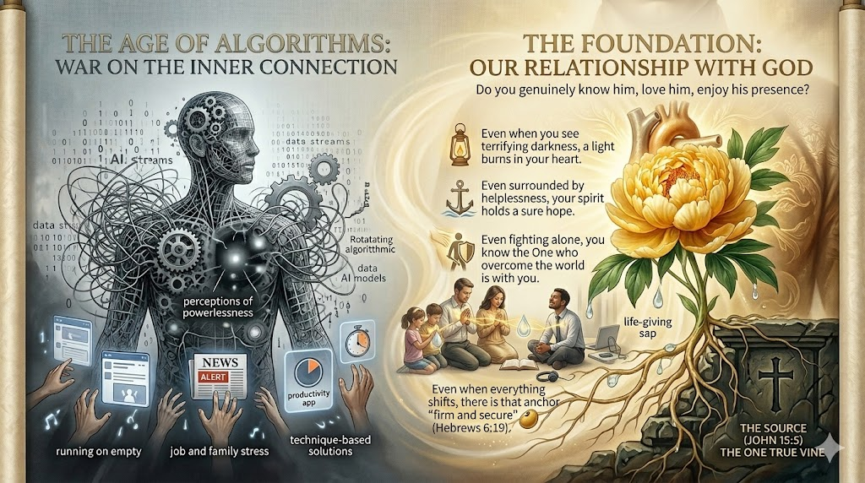

“The smallest turn toward Him is the beginning of a kingdom.” — Based on Luke 16:10 & John 15:5

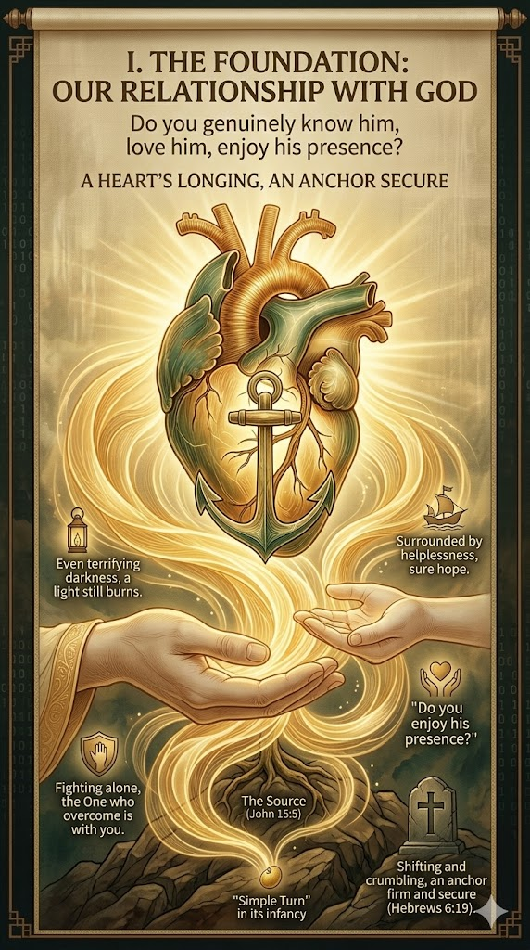
Do you enjoy his presence?
✨ “Even in terrifying darkness, a light still burns — because He holds your heart.” — Hebrews 6:19 | Psalm 27:1

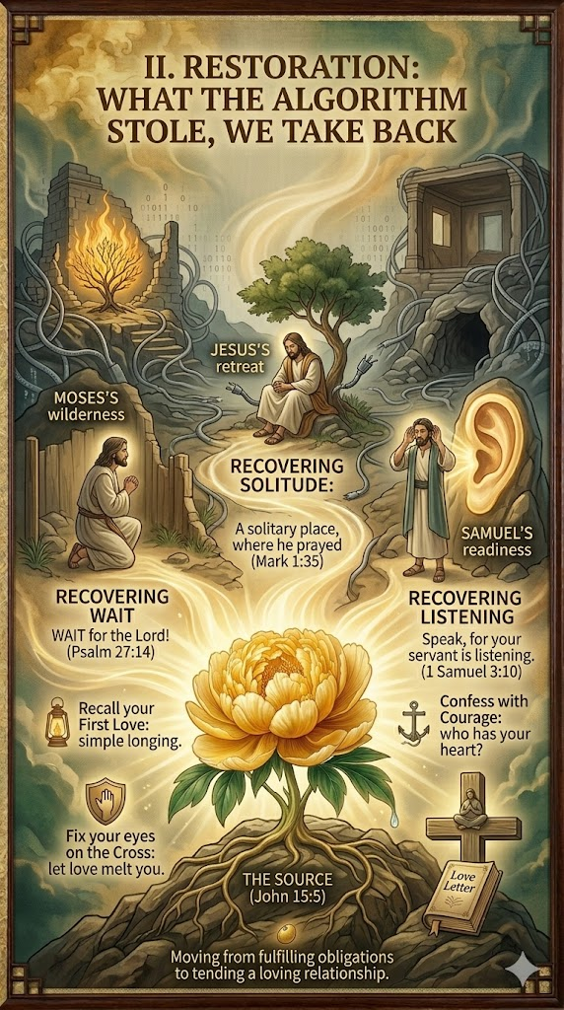

“God’s love letter to you”
“He didn’t steal your soul — but He did steal your silence. Reclaim it.” — Mark 1:35 | 1 Samuel 3:10

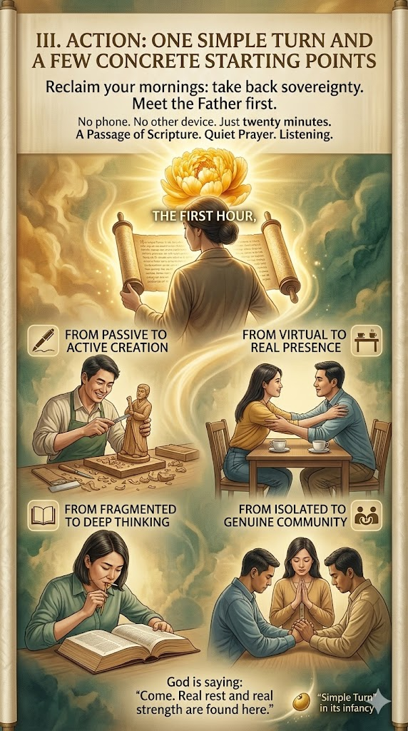
“Twenty minutes without screens is twenty minutes with the Source.” — John 15:5 (practical application)

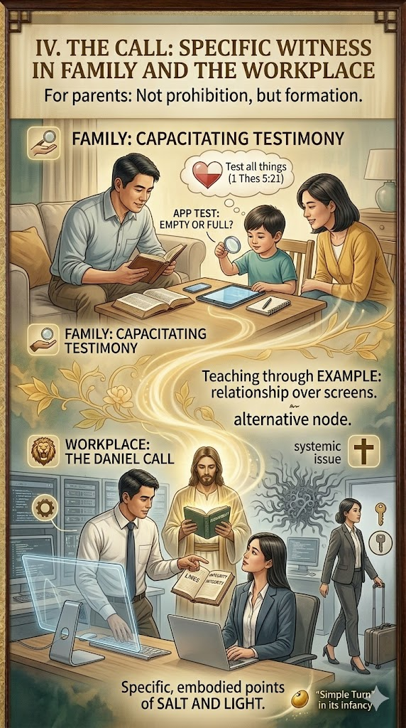
“Your example is louder than your rules. Let love melt the screen.” — 1 Thessalonians 5:21 | Matthew 5:16
We’re not fighting individuals—we’re redeeming systems.

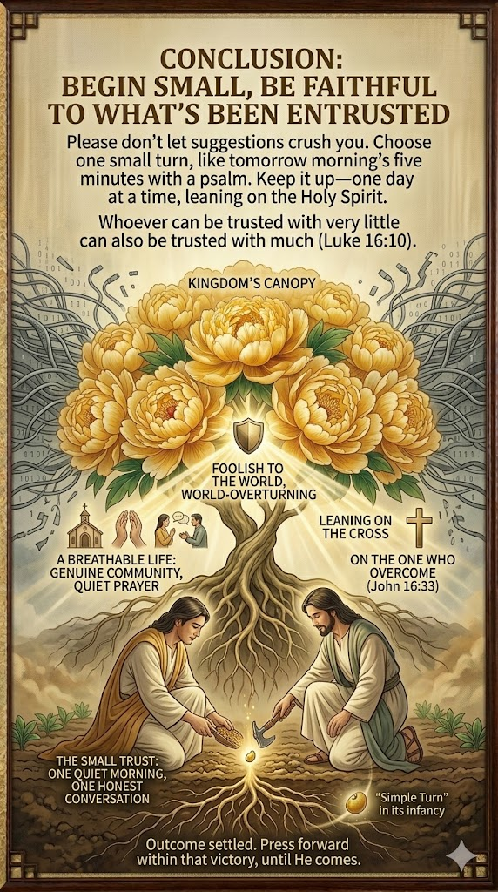
“Outcome settled. Press forward within that victory — until He comes.” — John 16:33 | Revelation 22:20

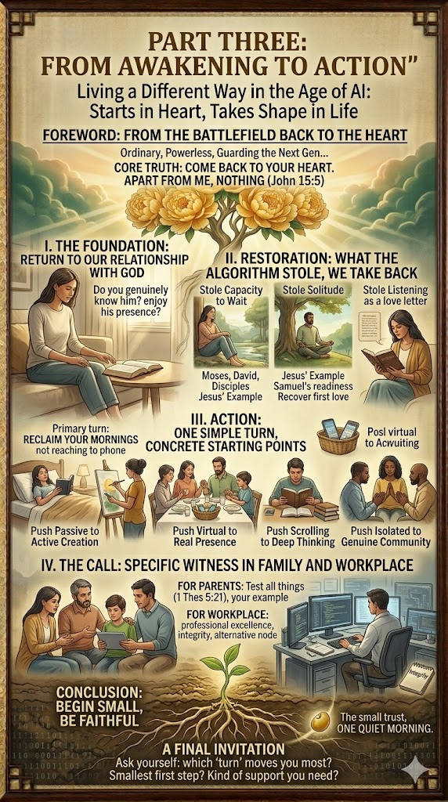
FROM AWAKENING TO ACTION: A Six-Step Journey Back to the Heart"
Which turn moves you most? Start there today.

